**Electric Circuit Experiments**

Basic Concept And Laws

1. Verify Kirchhoff’s law

A report by

**KIBRIA GOLAM**

**Student ID: 2019380163**

**Experiment Principal:** There are two laws of Kirchhoff; respectively Kirchhoff’s Current Law (KCL) and Kirchhoff’s Voltage Law(KVL).

#1. Kirchhoff's current law states that, for any node (junction) in an electrical circuit, the sum of currents flowing into that node is equal to the sum of currents flowing out of that node; or equivalently: The algebraic sum of currents in a network of conductors meeting at a point is zero.

#2. Kirchhoff's voltage law states that the algebraic sum of the potential differences in any loop must be equal to zero.

The objective of this experiment is to verify the above rules.

**Circuit:**

Circuit For Kirchhoff’s Current Law

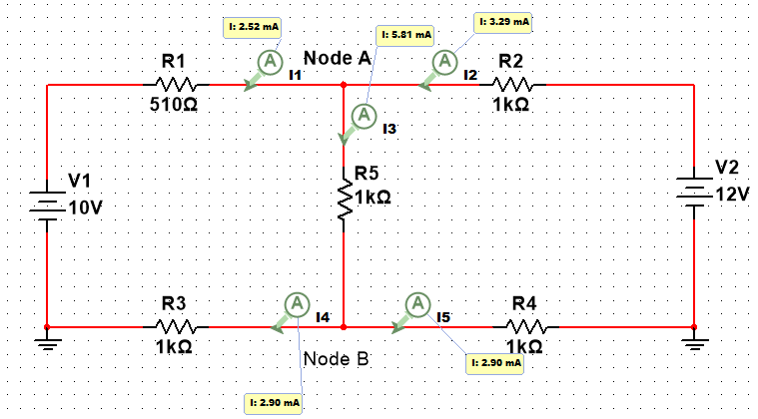

Circuit For Kirchhoff’s Voltage Law

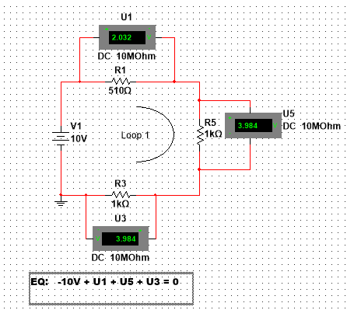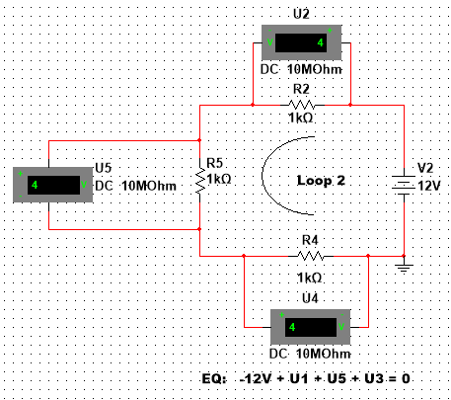

**Simulation Steps:**

1. Open NI Multicim 14.0
2. Draw the circuit for Kirchhoff’s Current Law.
3. Start simulation and put the data in the datasheet.
4. Draw the circuits of Kirchhoff’s Voltage Law.
5. Start Simulation and put the data in the datasheet.

**Simulation Data:**

**For KCL:**

|  |  |  |  |  |
| --- | --- | --- | --- | --- |
| **I1** | **I2** | **I3** | **I4** | **I5** |
| 2.52mA | 3.29mA | 5.81mA | 2.90mA | 2.90mA |

|  |  |  |  |
| --- | --- | --- | --- |
| **V1** | **U1** | **U3** | **U5** |
| 10V | 2.032V | 3.984V | 3.984V |

**For KVL:**

Data Of Loop 1

Data Of Loop 2

|  |  |  |  |
| --- | --- | --- | --- |
| **V2** | **U2** | **U4** | **U5** |
| 12V | 4V | 4V | 4V |

**Analysis and conclusion:**

In the circuit of KCL it is evident that

In node A, +I1+I2-I3=0 or, +2.52 +3.29 -5.81=0

In node B, +I3-I4-I5=0 or, +5.81 - 2.90 -2.90=0

So, Kirchhoff’s Current Law proves.

For the circuits of KVL, in the loop 1,

-10V + U1 + U5 + U3 = 0

=> 10V = 2.032V + 3.984V+ 3.984V

=> 10V = 10V

In the loop 2,

-12V + U1 + U5 + U3 = 0

=> 12V = 4V + 4V + 4V

=> 12V = 12V

So, Kirchhoff’s Voltage Law proves.

**Electric Circuit Experiments**

Basic Concept And Laws

1. Measure current in each branch.

Testify that for node A and B,

the algebraic sum of all branch current is zero.

A report by

**KIBRIA GOLAM**

**Student ID: 2019380163**

**Circuit:**

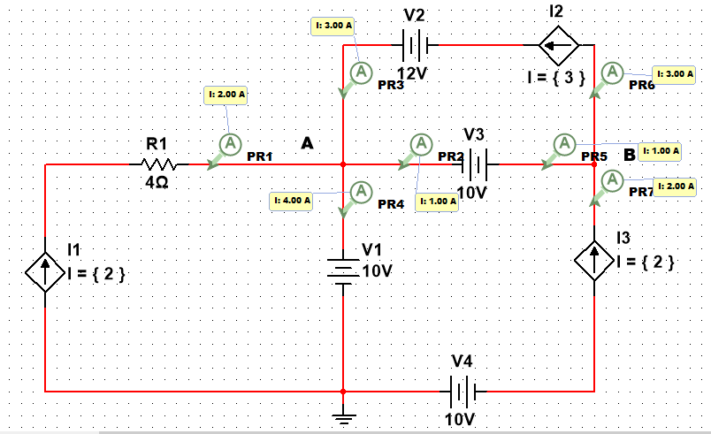

**Datasheet:**

Node A:

|  |  |  |  |
| --- | --- | --- | --- |
| I1 | I2 | I3 | I4 |
| 2A | 1A | 3A | 4A |

Node B

|  |  |  |
| --- | --- | --- |
| I5 | I6 | I7 |
| 1A | 3A | 2A |

**Analysis:**

The current law of Kirchhoff states, the algebraic sum of incoming and outgoing current in a node of a circuit will be zero.

According to KCL, in node A, +I1 + I3 - I2 - I4 = 0

and in node B, + I5 + I7 - I6 = 0

Calculating data from the datasheet,

In node A, + 2 + 3 – 1 – 4 = 0;

And in node B, + 1 + 2 – 3 = 0.

From the calculation above it is evident that in node A and node B the algebraic sum of current is 0.